Chapter 19, Solution 24.

Since this is a reciprocal network, a  network is appropriate, as shown below.

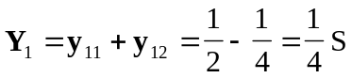, 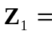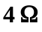
Y₁
Y₃
Y₂
(a)
1/4 S
1/8 S
1/4 S
(b)
4 
8 
4 
(c)
 